

**Bilkent University**

**CS 491**

**Senior Design Project I**

**Fall 2013**

**On Fire**

***Project Specifications***

October 7th, 2013

Group Members  
Baha Uluğ | Barış Şahin | Bengisu Şahin | Berkin Şansal | Sıla Şirin

Supervisor  
Fazlı Can

Jury Members  
Tuğrul Dayar | Hakan Ferhatosmanoğlu

Innovation Expert  
To Be Determined

List of Tables

List of Figures 2

Abstract 3

1. Introduction 3

1.1. Description 3

1.2. Constraints 4

1.2.1. Ethical Constraints 4

1.2.2. Economic Constraints 4

1.2.3. Social Constraints 4

1.2.4. Sustainability Constraints 5

1.3. Professional and Ethical Issues 5

1.3.1. Professional Issues 5

1.3.2. Ethics 6

2. Requirements 7

2.1. Functional Requirements 7

2.2. Non-Functional Requirements 8

3. Similar Applications and Differences 10

4. Mockups 11

5. Conclusion 14

6. References 15

# List of Figures

Figure 1 - Home view of On Fire 11

Figure 2 - Profile view of On Fire 12

Figure 3 - Live view of On Fire 12

Figure 4 - Nearby view of On Fire 13

Figure 5 - Settings view of On Fire 13

# Abstract

For our senior project, we aim to design and implement an application for mobile devices which enables users to have an idea about a place at a particular moment by video sharing. Additionally, with the social media integration, the system we propose will help users to share their locations and see their distance from their connections.

In this report, we will focus on the constraints, professional concerns, ethical issues and initial requirements of our project.

*List of Keywords:* On Fire, Fire, Foursquare, Facebook, Amazon, Augmented Reality, Nearby, Place, Friend, Check-In, Video, Map, Camera, Location, Privacy, Development

# Introduction

By the enhancement of Smart Phones and Internet speed, users can get any information when they need it. However, because of the information pollution, it is very hard to get exact information about something. Especially, in social media there is too much misleading information that leads misconceptions. Our project aims to solve this problem on location-based social media.

As a solution of this problem, our senior project will be a mobile application that allows users to see what is happening in a place in a particular moment by video sharing with social media integration from users and owners of the places. Therefore, videos are best way to give some idea about a place; users could not mislead by other users.

## Description

Our application will allow users to have an idea about the places according to shared videos. For owner of the place, application will allow adding an advertisement video to introduce the place on the place’s page. This feature will be very beneficial for owners because they will be able to advertise their place to their target population. On the other hand, users can see and search place’s locations from a map which is integrated with Google`s map service and also name of the places can be seen from this map. Users can check-in and see their connections’ check-ins in order to show what places they are hanging out. Besides, user can check nearby users either on map or on the camera.

For accurate information about places, we will get places’ locations from Foursquare`s database [2] and also for storing data such as videos, locations, user accounts and server issues we will use Amazon`s Elastic Compute Cloud (EC2) system [3].

## Constraints

### Ethical Constraints

Users will need to have an account to use On Fire and On Fire will also ask users to connect via Facebook accounts to avoid any fake account, so developers must keep this information safe. In this case, developers conduct their studies under ethical principles. It is known that in Internet information spreads very fast, so it may cause privacy concerns. To avoid this problem, it is very important that ethical issues should be considered.

### Economic Constraints

In developer point of view, the main cost will be renting a server, domain, cloud storage and database from Amazon web services [3]. This server has to be maintained because account information is kept in database of this remote server. On the other hand, considering that there are many people having social network accounts, On Fire will be used by many people and have income.

### Social Constraints

On Fire will encourage users with different social networks such as Facebook and this will enable users to have more information with their networks via On Fire. So on this way it is very beneficial not only for following friends instantly, but also to be aware of news, headlines and significant progresses related to public issues.

### Sustainability Constraints

On fire is required to use interaction and flow of information through the internet. Therefore, maintenance of this server is very important. Also the server has to do lots of work because there can be many users and this will affect the performance. In addition to this the quality of our videos should be high and it will also affect the performance. Lastly, any error in software has to be fixed immediately therefore; having back-up systems may also be considered.

## Professional and Ethical Issues

### Professional Issues

* We will give outmost importance to make a strong cooperation between group members. It is quite important in terms of preventing imbalanced timing and uncoordinated workflow. Therefore, we have to proper share of work between group members. Additionally, before the sharing of works, it is certain that we will have to arrange our time by determining the number of hours we will spare, according to the workload the project is going to have.
* We are honest and trustworthy because it is a necessary part in order to gain confidence of users who will use our system.
* During doing the project, maintaining an authority over team members can be an important criterion to guarantee complete work with a high quality. Therefore, besides of fulfilling their own responsibilities, team members should check other team members’ works.
* All team members should consider the issue of being innovative. Therefore, our criterion in terms of innovativeness is consisted of perfectionism, efficiency, radicalism and size of adopters.

### Ethics

* The information we will get from the user will be an issue for us because our application will be social networking platform which has similar features with social networks like Facebook and Twitter regarding the information that will be received from the users, as well as privacy concerns. Therefore, we are going to leave most of the choice to users as we will have options for publicity of their profiles.
* In order to maintain order of the accounts, we will have Facebook integration. This integration will provide misuse of the program and as well as protection of other users privacy.
* We will consider the Policy on Academic Honesty of Bilkent University

# Requirements

## Functional Requirements

* **Video Check-in**

The main purpose of the application will be video check-in. When user wants to check-in in a place where he is, he has to share a video of that place which will take between 3 to 15 seconds. This video can be shared either public, so it will be saved under place page, or just for friends.

* **Creating Profile & Facebook Login**

When application runs for first, it will ask for signing in or signing up. User can use their Facebook account to log in easily and directly.

* **Looking Nearby Places & People**

Users can open maps or camera which will be provided inside the application in order to see nearby places and people. Camera will be developed thanks to augmented reality technology [4].

* **Following Places & Making Friends**

User can follow places to see updates and recent videos in that places. In addition, users can add friends to follow their actions.

* **Searching Places**

By searching places, user can reach what’s happening in places which are not even nearby to user’s location.

* **Settings**

By settings, user can find their friends, change their account, privacy and notification settings, and reach information about application and user terms.

## Non-Functional Requirements

* **Performance**

Our application will require low system preferences on mobile. We will try to make codes simple to work on almost all previous generation of mobile phones existing in these days. Because of maps-in-app and camera-in-app, system will require more RAM but we want them to use considerably low memory. Moreover, our application should upload videos fast, so size will be limited to reduce both upload time and requirement of data from user’s network package.

* **Usability**

Young and adult users can use this application without any trouble. In simple “Help” part in “Settings”, the whole information about the app will be given with icons and pictures. In order to be user friendly, there is no unnecessary buttons in the screens. Moreover, most of the mobile phones can meet the application system requirements.

* **Data Management**

Data management will be handled both by storage of telephone and by web server. Amazon web services will be used as server, cloud storage and database [3].

* **Reliability**

Because of low system requirements, our application will not face with complicated situation or any time delay during the process. However network connection will be the most important part of the application to overcome the upload, check-in, and retrieving information problems, but with network checking in every steps, we will prevent the troubleshoots.

# Similar Applications and Differences

* **Foursquare [5]:** Our program and Foursquare have mainly similar concept in terms of check-in. In addition to Foursquare, our program is unique on uploading videos at a particular moment. By this way, videos will have a role which will lead a place to come into prominence.
* **Around Me [6]:** This program shows places on camera by augmented reality. We will have a feature that which will show places and users. By launching the camera in the app, nearby places and people will be appear according to their locations. Location-based augmented reality technology will help us to improve this [4]. Your friends, other crowd, and favorite places will be under your hand with their accurate locations and directions.

# Mockups

* iPhone image used in mockups was taken from a website [1].

Home Screen

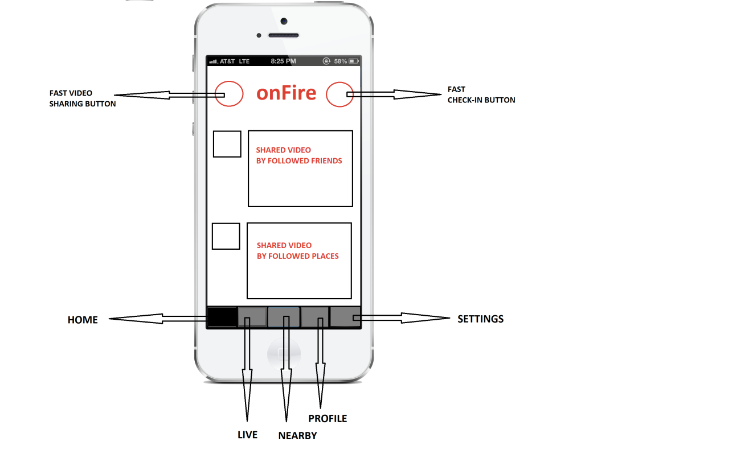

Figure 1 - Home view of On Fire

Profile

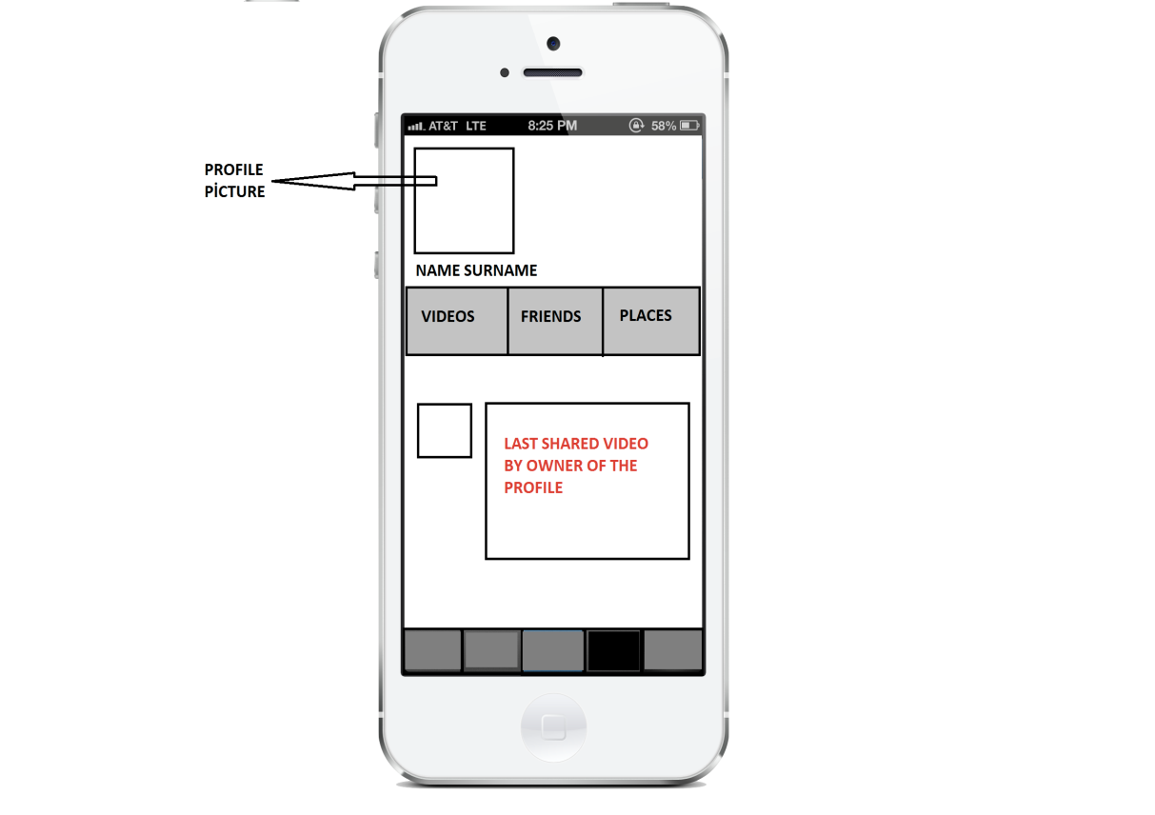

Figure 2 - Profile view of On Fire

Live

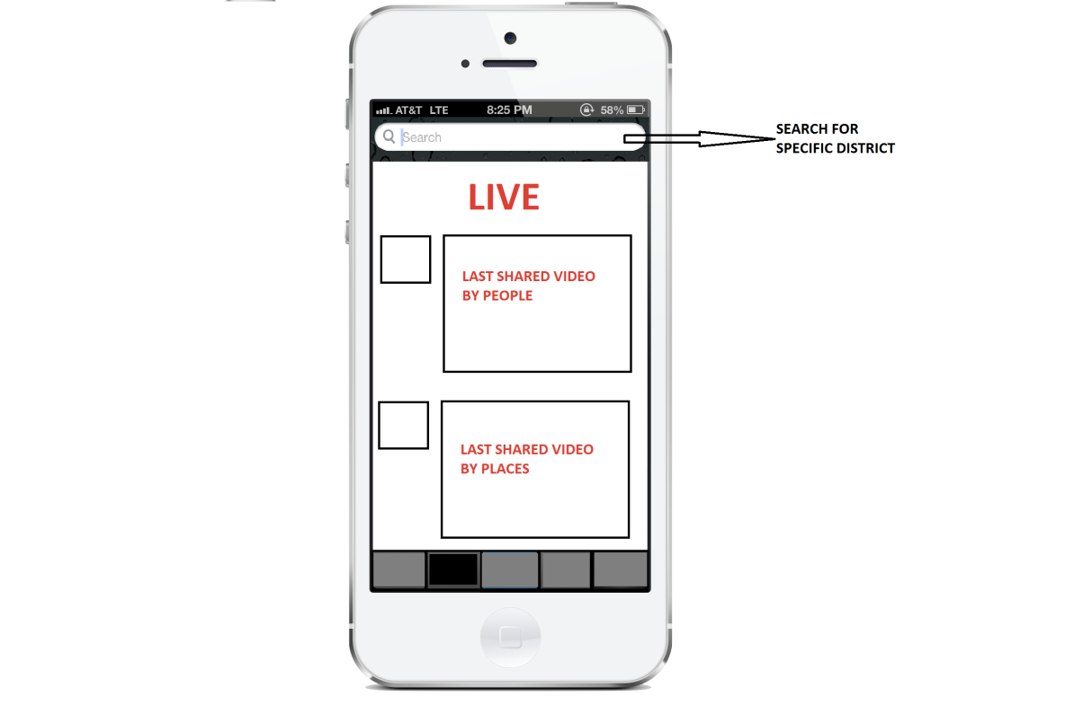

Figure 3 - Live view of On Fire

Nearby

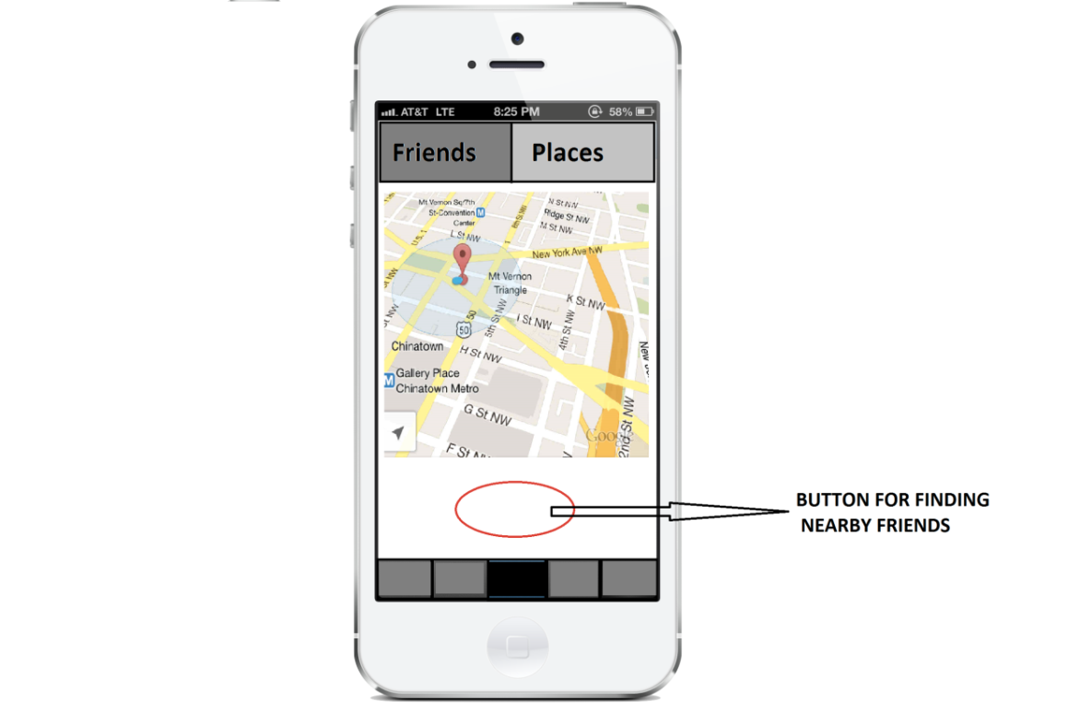

Figure 4 - Nearby view of On Fire

Settings

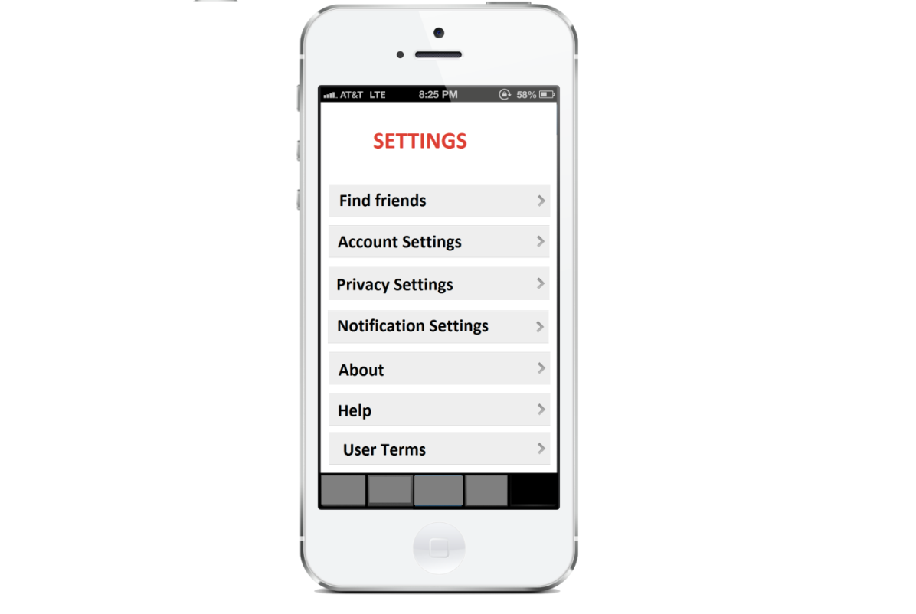

Figure 5 - Settings view of On Fire

# Conclusion

To conclude, we have chosen a mobile application as our senior project because with this program, people will be able to see what is happening in a place in a particular moment by video sharing with social media integration from users and owners of the places. For this reason, we believe that videos are the best way to give some idea about a place. Thanks to this application, people can share videos in a place on a particular time, places’ owners can advertise their places and user can check nearby users either on map or on the camera. Moreover, users can check-in where they are and can see their connections’ check-ins. This application will consider social, ethical, economical issues and so on to avoid unsafe situations. We believe that our application will be used by many people because in today’s world, lots of people are following social media by using smart phones in their daily lives.

# References

[1] . (2011). *Apple iPhone 4S* [Online]. Available:  
<http://www.geekandhype.com/apple-iphone-4s-8830/iphone-4s-white/>

[2] . (2013). *Foursquare API* [Online]. Available:   
<https://developer.foursquare.com/>

[3] . (2013). *Web, Mobile, and Social Apps on AWS* [Online]. Available: <http://aws.amazon.com/web-mobile-social/>

[4] . (2013). *Augmented Reality iOS Tutorial: Location Based* [Online]. Available: <http://www.raywenderlich.com/42266/augmented-reality-ios-tutorial-location-based>

[5] . (2013). *Foursquare* [Online]. Available:  
<https://itunes.apple.com/tr/app/foursquare-find-restaurants/id306934924?mt=8>

[6] . (2013). *Around Me* [Online]. Available: <https://itunes.apple.com/us/app/aroundme/id290051590?mt=8>